Entering 10th Grade English
SUMMER READING
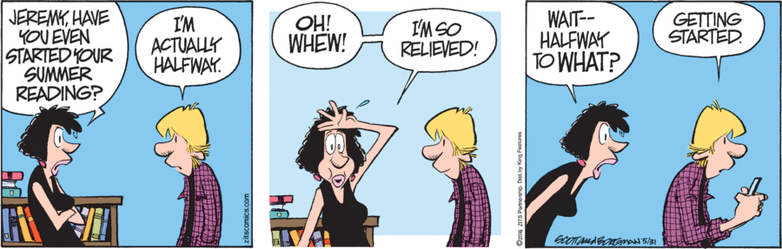

In order to be best prepared for joining our English classroom in the fall, you will read two works this summer and will complete your choice of assignments outlined below. These assignments are meant to (1) supply you with references for in-class discussions and (2) give you a head start on the first assignment of the fall semester. All Readings and Assignments will be due at the end of the first week of classes.

10th Grade Required Reading
    - Coelho, Paulo. The Alchemist. Thorsons, 1995.
After reading, select one of the following as a final project for our reading of the novel. Projects will be graded on the use or representation of details from the novel, the overall understanding of the novel demonstrated by the project (this can include theme, character awareness, etc.), creativity of the product (I want to see your ideas and work, not those of others repurposed for your project), and finishing touches (the effort you put in to making the project look great and feel cared for).

If you like comics… Graphic Novel / Comic Book
Recreate the story in a graphic novel (i.e. comic book) format. Choose the most important scenes – in your view– and tell the story of The Alchemist while sharing it with an audience through the combination of illustration and words. Use the language of the book where appropriate, and include details in the actual drawings. Part of your grade will be based on the quality/effort put into the artwork (no stick figures). Include an introduction in which you explain what you tried to capture in your recreation of the novel (e.g., “I wanted to emphasize the extent to which the character... I did this because… and showed it by…”), and what aspects of the novel (mood, imagery, etc.) you are trying to convey in your illustration.
If you like games… Board Game
Take your close reading of the novel and turn it into a game! Be sure to use specific details from the text. The purpose of this project is to help someone understand Santiago and his journey as well as you do, not to quiz people on facts. Consider giving players choices and challenges, rather than asking trivia questions. You may model your game on an existing game (i.e. The Game of Life) or create your own. The game should help others learn in an innovative way and think about the novel’s conflicts and themes. You must include all pieces and instructions in order for the game to be played effectively.
If you like arts & crafts… Santiago’s Scrapbook
Create a scrapbook of memorabilia that Santiago might have collected or come across during the novel. All artifacts must be captioned with where he got it, its significance to him, and the page you found it on from the novel. Think of the images that keep recurring in the novel and anything he protects or deems important. Be thoughtful in the choice of memorabilia for your scrapbook. Each item should be accompanied by at least a paragraph (3-5 sentences) using text evidence to explain its significance. This project will be assessed based on the amount of memorabilia collected (at least ten items) and the quality/effort put into making the scrapbook.
If you like social media… Instagram
Create an Instagram account for one of the novel’s characters. Your project should include at least twenty posts that relate in some way to one of the major themes of the novel. For each of your posts, you must include a caption with a description of the image and its connection to the theme, how it ties to the text, and the page numbers of the novel that it connects to. Think of a creative and appropriate username for the character, as well as a quote for his profile that he might pick if he were the creator of it. Your profile must mention that this is a school project in connection with The Alchemist, due to the numerous fake accounts that exist on social media. You must also make the account public so that I can access it. Please check out an example account (although it is for another book): @i_forgot_my_real_name. You can also avoid doing this online and make an Instagram replica specifically on poster board; for this, make sure you examine an actual instagram account and include all of the details necessary.
If you Like Music Santiago’s Playlist
Create a playlist of 10 songs that you think represent the novel. Songs should be school appropriate (get clean versions if necessary). With each song, you should write a short paragraph explaining what from the novel you think is represented in the song. You can compile your playlist in a google doc with links to the music, in a powerpoint, or any other way that allows you to present the music and descriptions in a creative, organized way.

If you like creative writing… Lights! Camera! Action!
Think of yourself as a director. You get to call the shots in making a film inspired by the novel The Alchemist. Think about how you would portray the characters, themes, and mood found in the novel. Does music play in the background? What kinds of camera angles are used to help tell the story? What does the lighting look like?
In at least 500 words, write a mini screenplay for what you think the climax of the novel would be. Be sure to use stage directions (in parentheses) to help clearly “create” your picture. You should use at least 1 quote from the novel, either in dialogue or as a part of the stage directions.

10th Grade Choice Reading
You may choose one of the following books and complete a book report as detailed below.
Book Report Structure -
2-3 pages in length, MLA Format (times new roman, 12 point font, double spaced)

- INTRODUCTION
  - First sentence: Name of book, type of book (historical novel, biography, etc.), author
  - Second sentence: number of pages, main subject, main character's name
  - Third sentence: Describe the setting and theme (this is often easier to write after you've written the rest of the report)
- PARAGRAPH 2: PLOT
  - At the opening of the book, what is happening? (1-2 sentences) \
  - What trials does the main character face throughout the book? (3-4 sentences)
  - What is the climax of the book? (1 sentence)
  - How does the book resolve? (1 sentence)
- PARAGRAPH 3: THEME: WHAT IS THE NATURE OF THE STRUGGLE THAT THE CHARACTER IS FACING?
  - Point 1: what is the character like in the beginning? List one specific thing that happened that shows you this.
  - Point 2: What effect do the challenges that the main character face have on that character? List three specific events and their effects.
  - Point 3: How does the main conflict in the book change the character? What does this tell you about the theme that the author is trying to convey?
- PARAGRAPH 4: CONCLUSION
  - What did you like about the book?
  - Restate the theme and how it is resolved.
  - What makes the book special (or not special)?
  - Who would you recommend this book to and why?
BOOK CHOICES
Choose one book you have not read before.
Nonfiction
- They Called Us Enemy by George Takei (Graphic Novel)
- The Freedom Writers Diary by Erin Grewell
- The Men We Reaped by Jesmyn Ward

Teenage Protagonist
- The Power of One by Bryce Courtenay
- The Namesake by Jhumpa Lahiri
- Speak by Laurie Halse Anderson
- Over the Water by Casey Maude
- Curious Incident of the Dog in the Nighttime by Mark Haddon
- The Perks of Being a WallFlower by Stephen Chbosky
- Turtles All The Way Down by John Green
- This One Summer by Mariko Tamaki (Graphic Novel)

Romance
- Pride and Prejudice by Jane Austen
- The Hunchback of Notre Dame by Victor Hugo
- The Sun is Also A Star by Nicola Yoon

Science Fiction & Fantasy
- The Young Elites by Marie Lu
- The Lost Hero by Rick Riordan
- Lord of the Rings by J R R Tolkein
- The Hitchhiker’s Guide to the Galaxy by Douglas Adams
- The Fifth Wave by Nick Yancey

Adventure
- The Story of King Arthur and His Knights by Howard Pyle
- Heart of Darkness by Joseph Conrad
- The Call of the Wild by Jack London

Mystery
- And Then There Were None by Agatha Christie
- The Hound of Baskervilles (Sherlock Holmes) by Sir Arthur Conan Doyle
- One Of Us Is Lying By Karen M. Mcmanus

