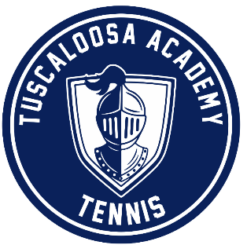
2022 Tuscaloosa Academy Tennis

Date Opponent Location Time
Mar. 3 Lakeside Away(O’Conner Tennis Center 1:00
Mar. 4 Morgan Away(Selma C.C.) 1:00
Mar. 8 Restoration/Southern Away(George Ward Park) 2/4:00
Mar. 10 Pike/Glenwood Away(O’Conner Tennis Center 12:30/2:30
Mar. 22 Lee-Scott Home(North River Yacht Club) 1:00
Mar. 31 Ft. Dale Away(Greenville) 1:30
Apr. 4 Monroe Away(Lagoon Park) 11:00
Apr. 11-12 State Tournament Away(Lagoon Park) TBA

